Installation OF NECESSARY TOOLS
PowerBI was already installed on computer. At first SSMS 18 installed.

Install Adventure Works DWH

Here I ran into multiple issues. Reinstalls, refreshes, online troubleshooting suggestions or AI involvement was not helpful at first. 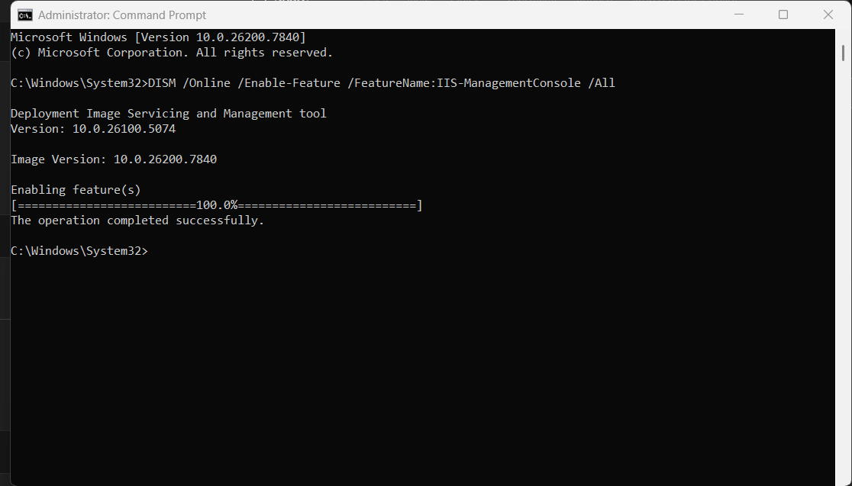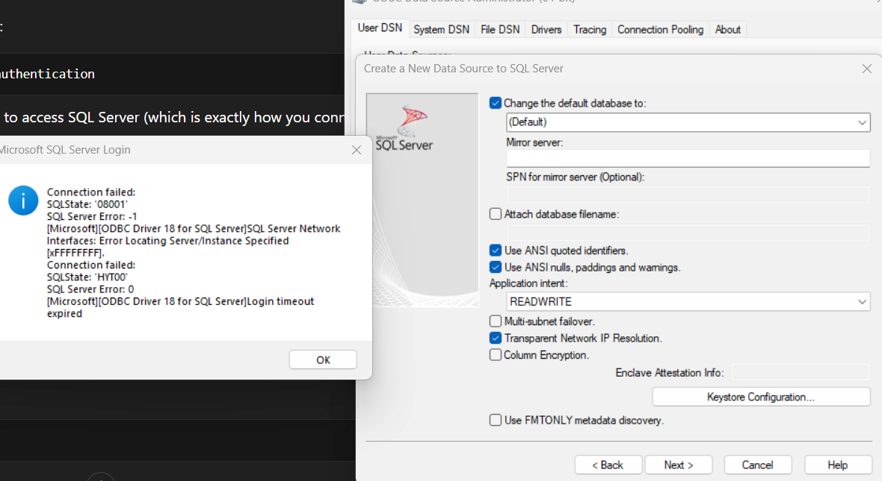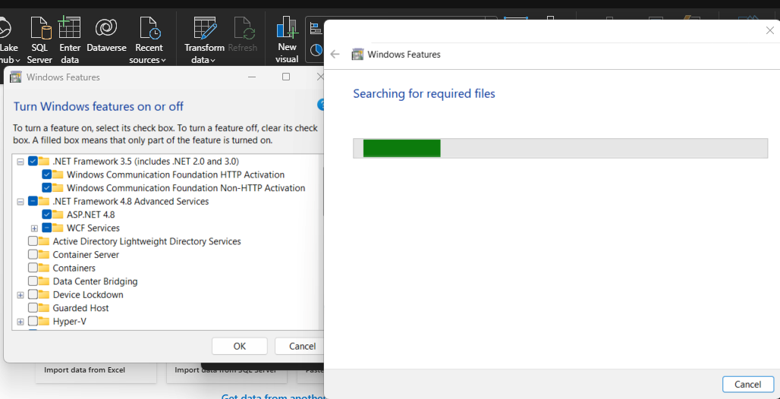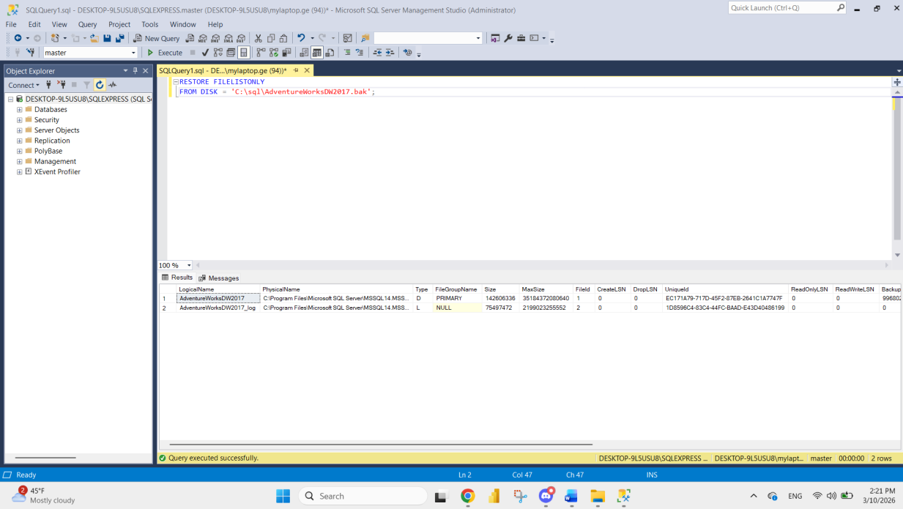

Finally, installing SSMS 22 on a different windows user than at first resolved the issue, database restored and imported into PowerBi.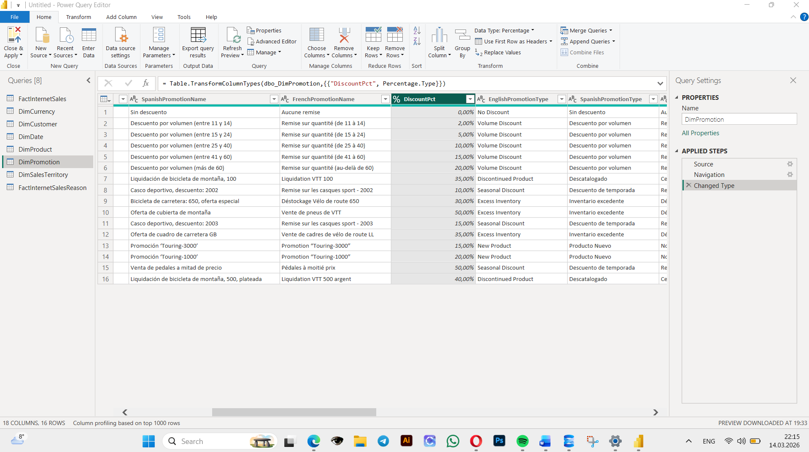

Building a simple Power BI Report

Load Data
Loaded data, chose the columns needed.

Basic Data Transformation
Merged first and last name columns.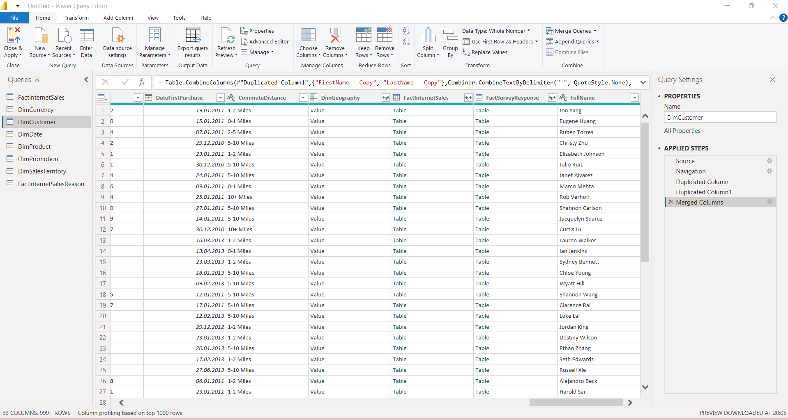
Column type changed to percentage.

Campaign duration calculated by adding a calculated column of subtraction – enddate from startdate.
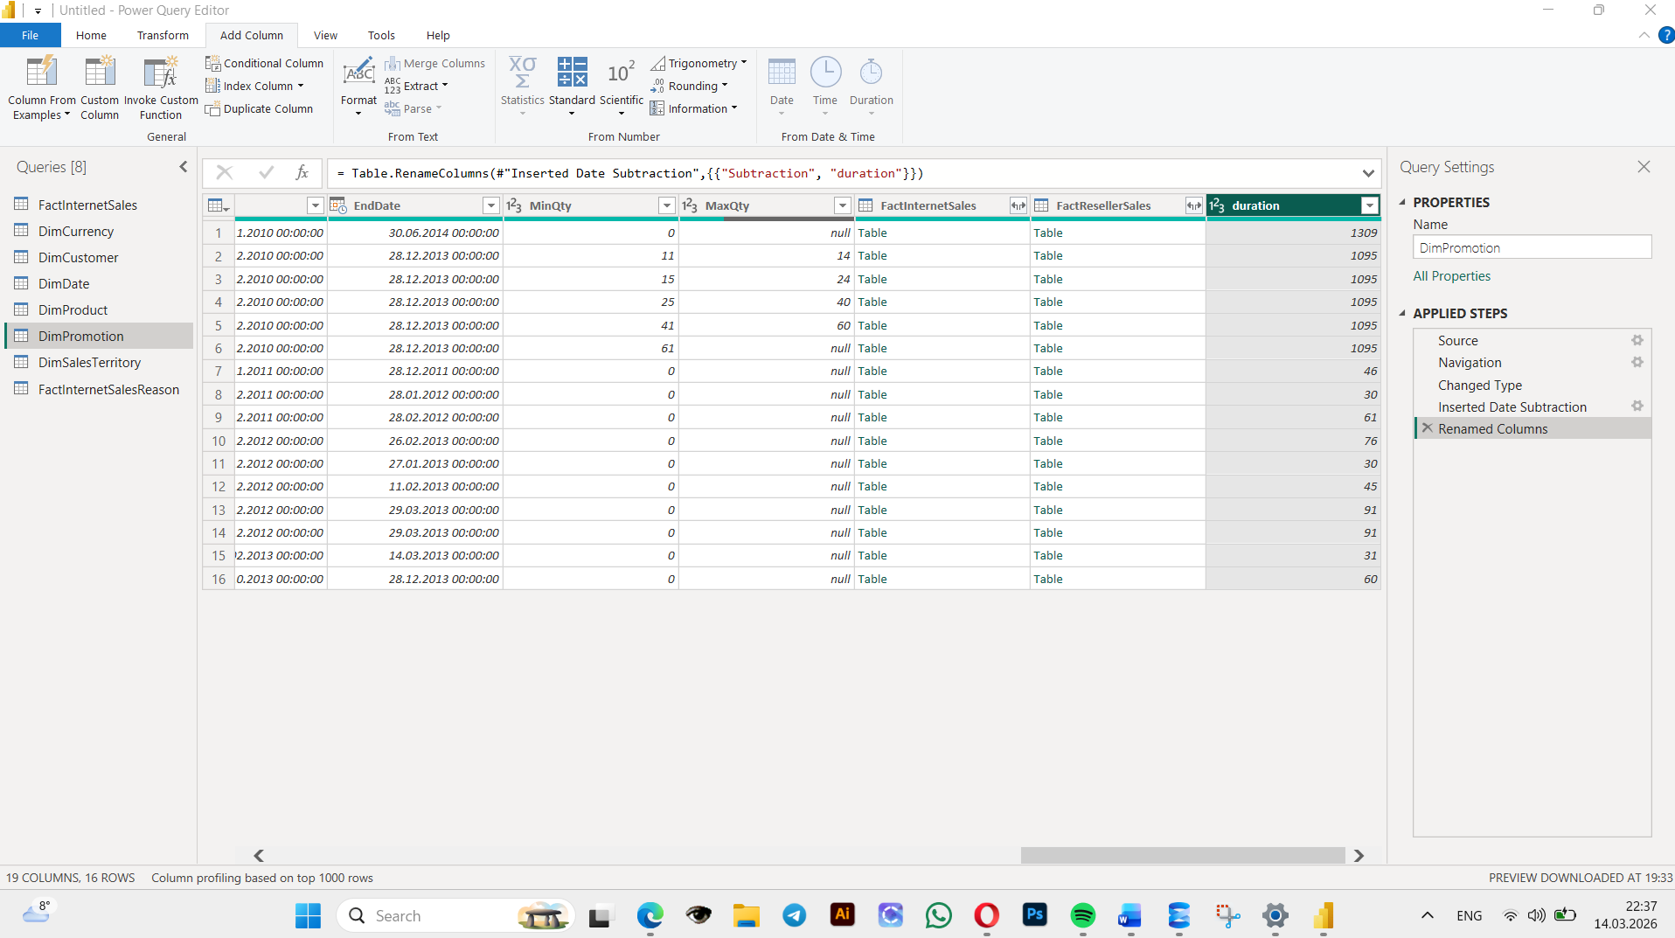

ADDING NEW TABLES
Get data > tables added from the same source.

DATA PROFILING
View settings adjusted.
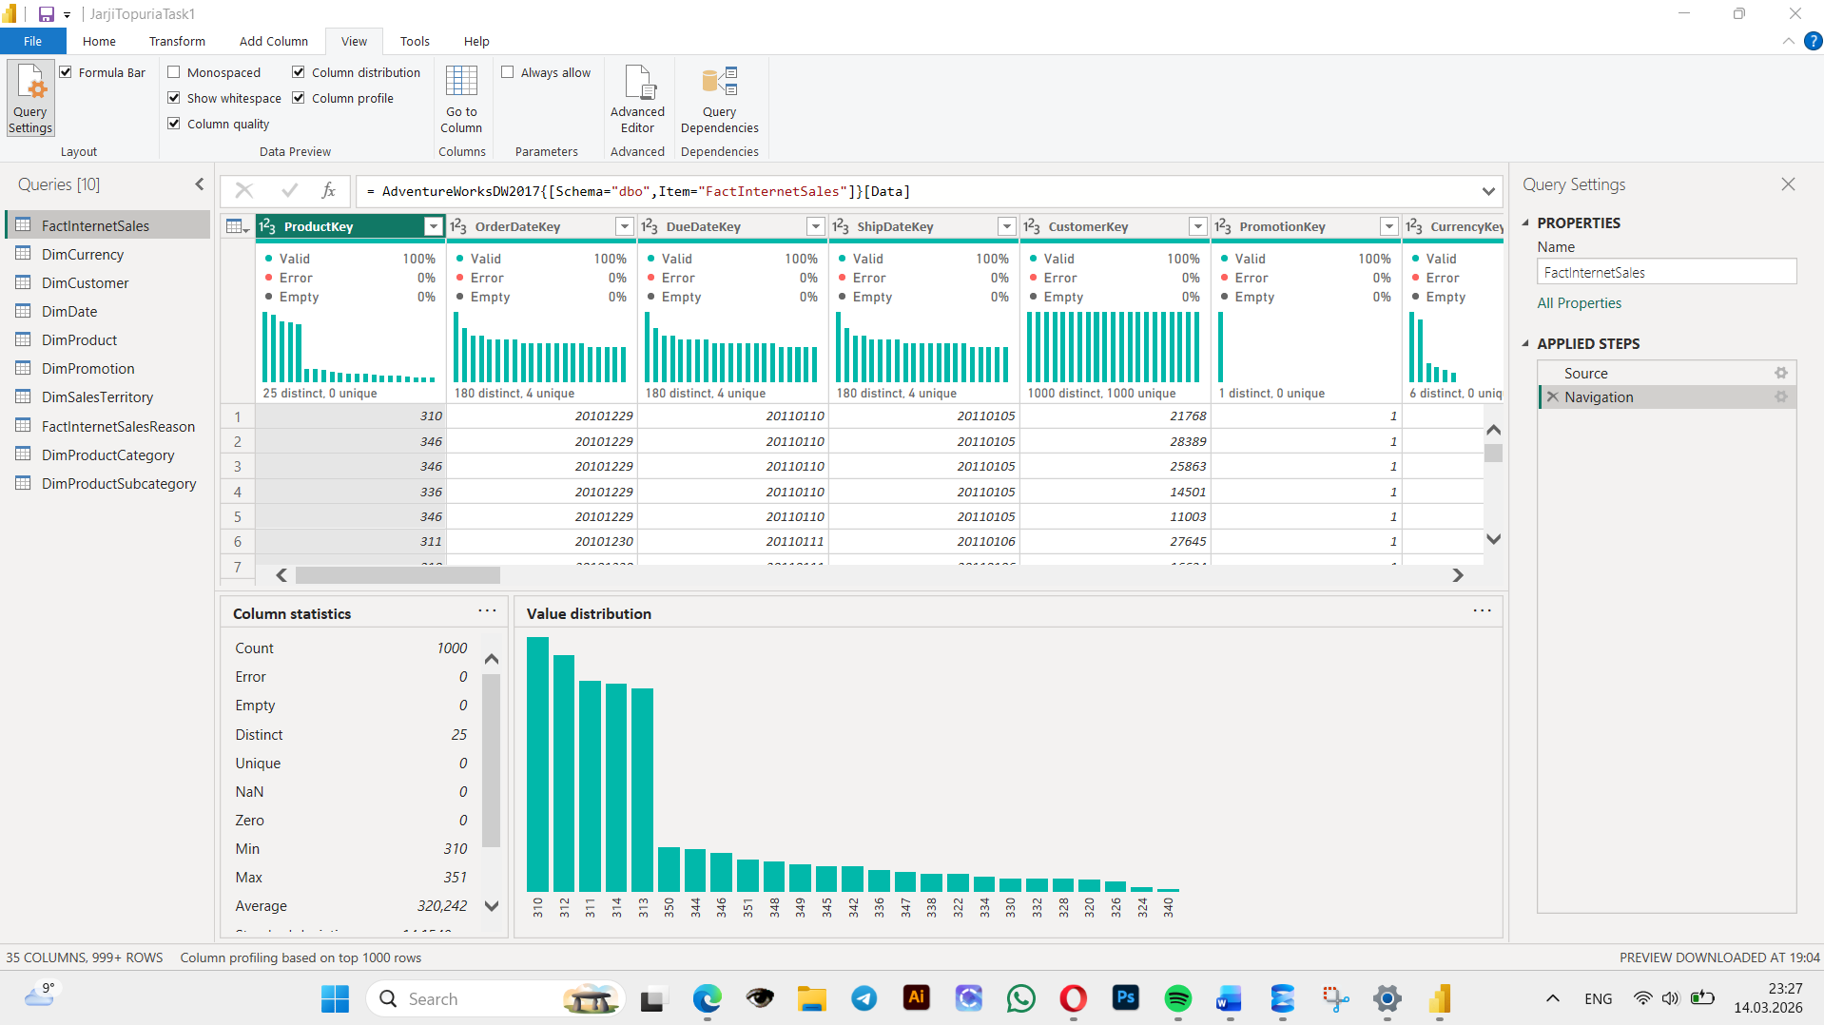

PIVOT COLUMN
Custom year column added using formula Date.Year([OrderDate])
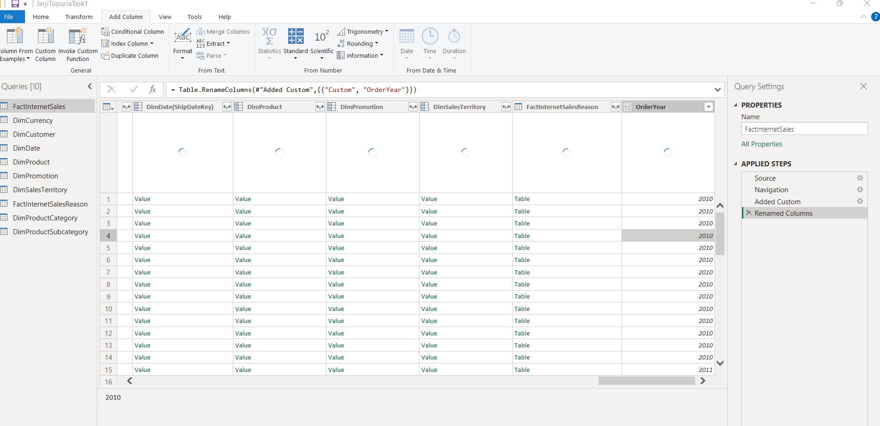

Requested columns isolated in a new table.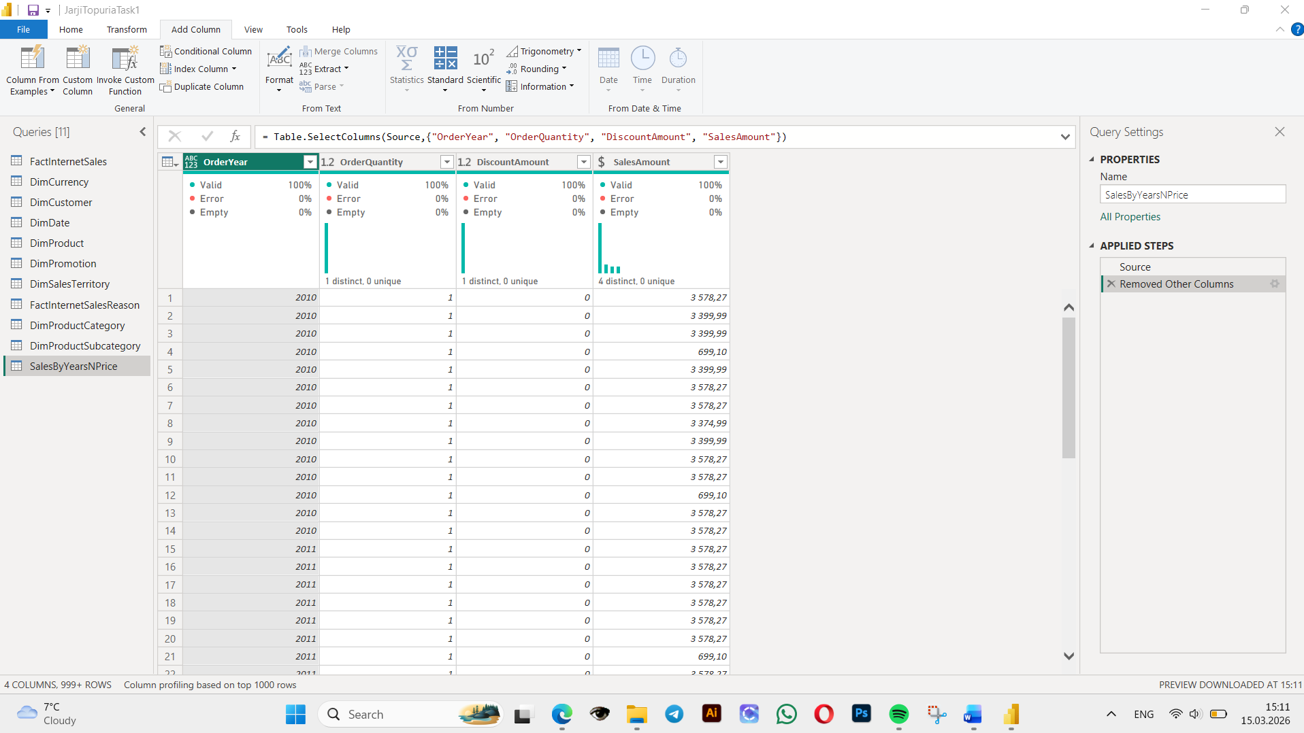

SalesAmount selected as value column.
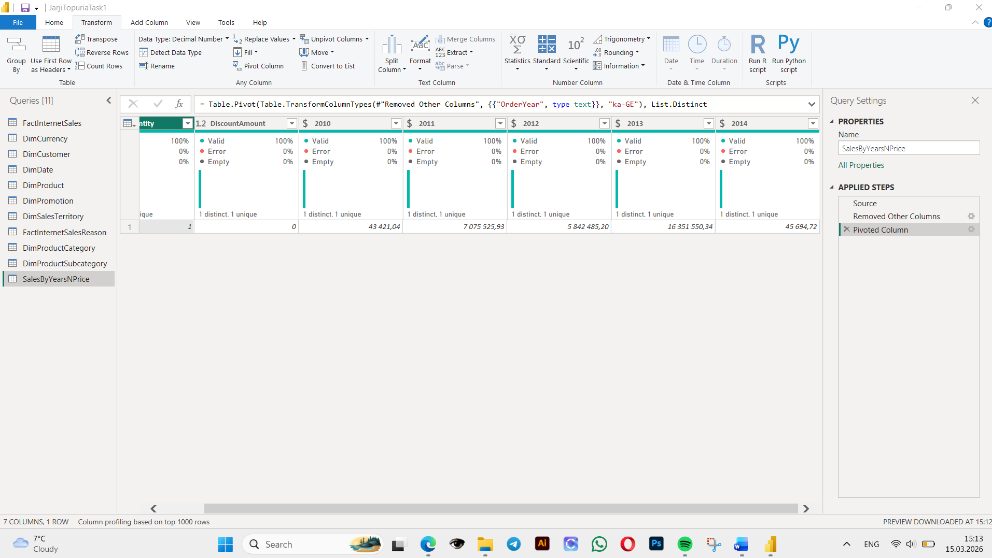

TABLE JOINING
Here are the results of the initial joins.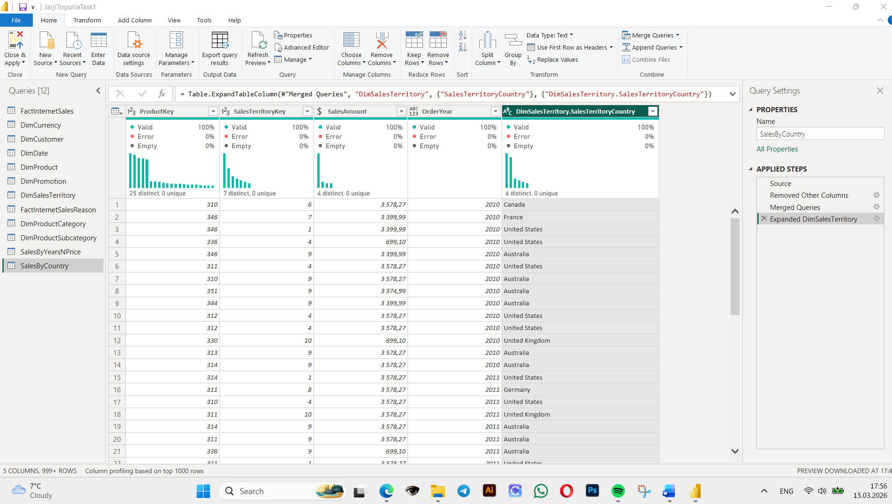
To add EnglishProductCategory 3 tables had to be joined indeed – new merged table to DimProduct and then DimProductSubcategory.
Subtypes used instead of general categories, same steps.
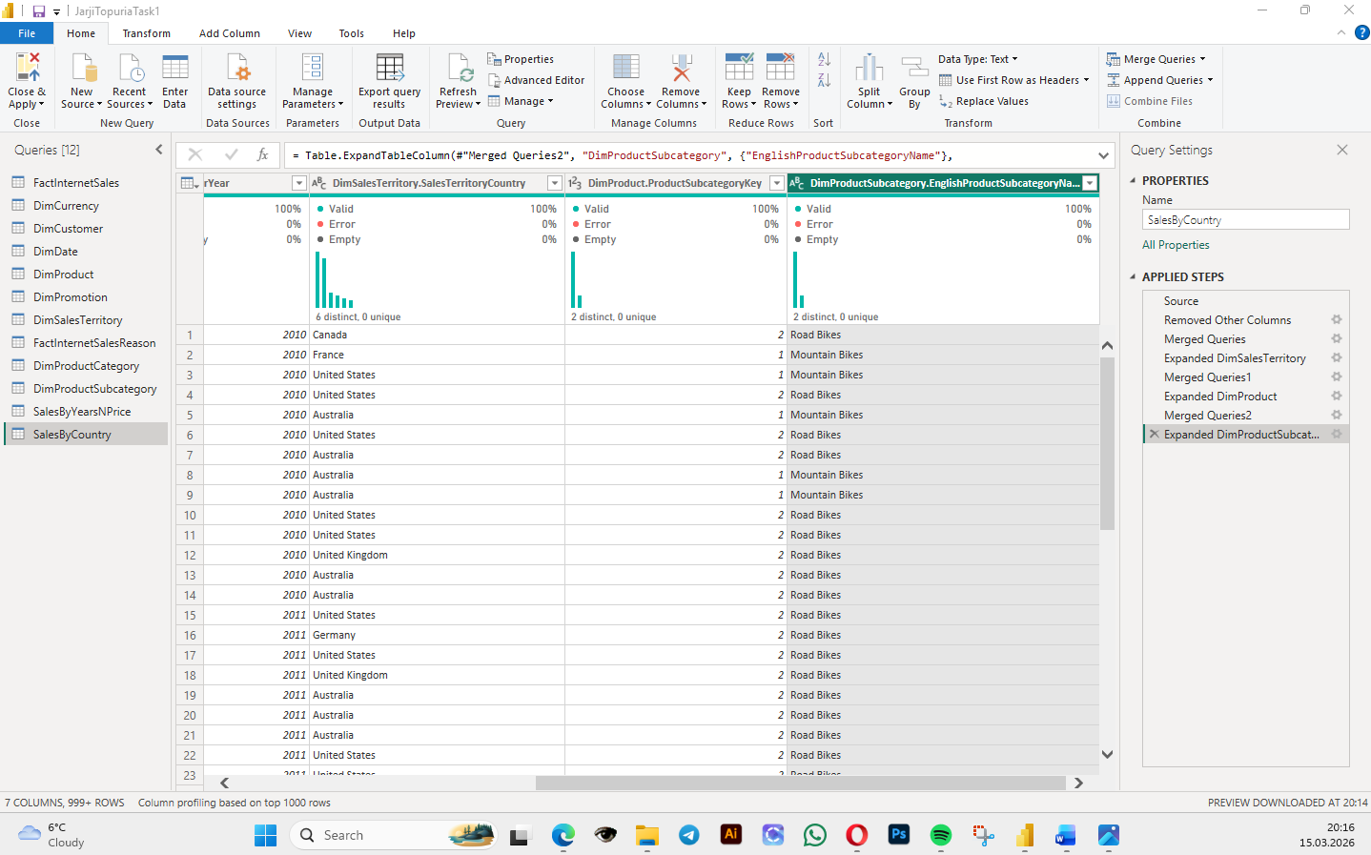

GROUPING DATA
Data grouped per year per country per product subtype. For each row sales are summed.
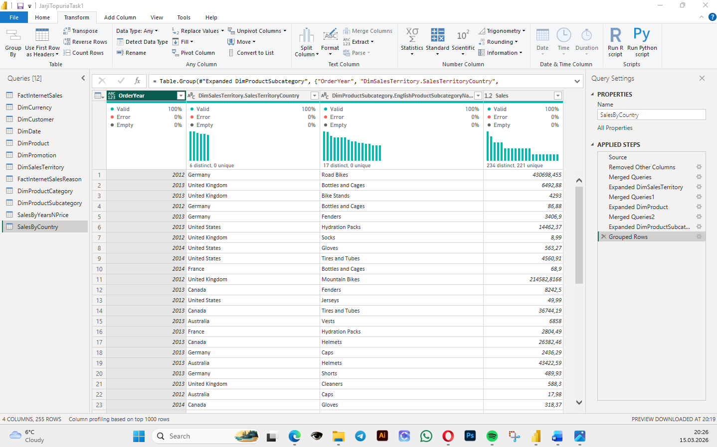

Load Data
Saved with correct name.

IMPORT VS DIRECT QUERY
Import actually moves the files in PowerBi, while Direct query keeps the data in the source and ‘looks’ at it.
After importing loading seemed faster than using direct query.
While not apparent for the steps taken within this task, there are features restricted or slow for direct query.

WORKING WITH POWER BI MODEL
Model is centered around the FactInternetSales table. Product > Category > Subcategory structure is there too. The aggregated tables are not connected to the core tables.
Shipdatekey and Duedatekey relationships removed between facts and date tables.
